Kids Food at THE PIG in the South Downs

1 PIGGY, 1 SHEEP & 1 BUMBLE BEE to build your Main Course!
£7.50 for 1 Course
£10.50 for 2 Courses

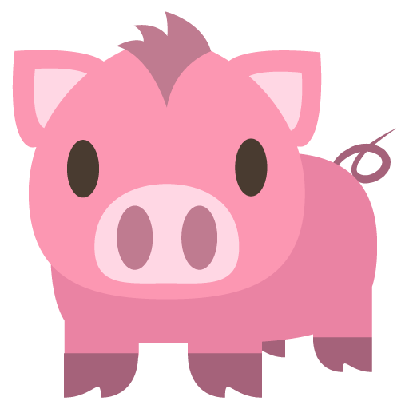 | 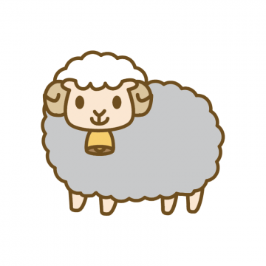 | 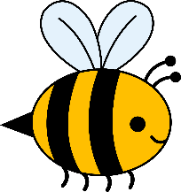
Sausage | Pasta | Garden Peas
Beef Bolognaise | Chips | Steamed Greens
Fish of the Day | Fried Hen’s Egg | Alex’s Salad

For more Vegetarian Options, please speak to your Waiter
PUDDINGS

Selection of Homemade Ice Creams or Sorbets
Chocolate Brownie & Homemade Ice Cream
Please Speak To Our Restaurant Manager If You Have Any Questions About The Menu, Allergies Or Dietary Requirements

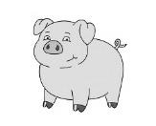

HAVE A GO AT OUR PIGGY PUZZLES & COLOURING!

Sorbet Carrot Chips
Jelly Steak Pig

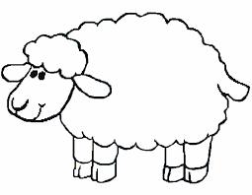

MY NAME IS
_________________________________
THE SHEEP!

