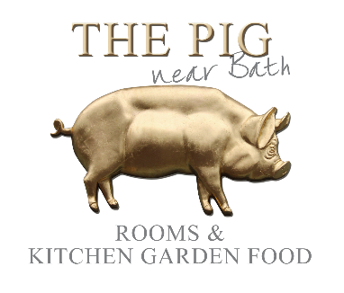

Kids Food at THE PIG-near Bath

1 COW, 1 TOMATO & 1 BROCCOLI to build your Main Course!
£7.50 for 1 Course
£10.50 for 2 Courses
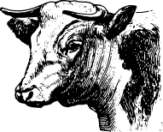 | 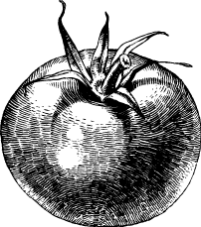 | 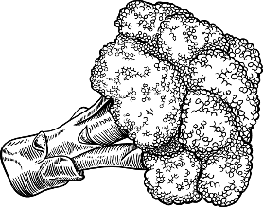
Sausage | Tomato Pasta | Tomato & Cucumber
Sirloin Steak | Pitta Pocket | Steamed Greens
Breaded Chicken | Chips | Zack’s Salad
Smoked Salmon | New Potatoes | Garden Peas
Homemade Fish Fingers | Fried Hen’s Egg | Baked Beans
For more Vegetarian Options, please speak to your Waiter
PUDDINGS

Selection of Homemade Ice Creams or Sorbets
THE PIG’s Mini Eton Mess
Chocolate Brownie & Homemade Ice Cream
Please Speak To Our Restaurant Manager If You Have Any Questions About The Menu, Allergies Or Dietary Requirements

